Building Maintenance Management System
Process Modeling and Data Modeling /
System Proposal / Analysis Phase
(Homework No.3)

Project team: Team 06
Instructor: Dr. Araz Yusubov

Submitted in partial fulfillment of the requirements of the INFT 2303: Systems Analysis and Design course project

GitHub repository | https://github.com/ADA-SITE-INFT2303-2023-Spring/sys-dev-project-team-06.git
Version date | Version information
22.04.2023 | Initial draft
23.04.2023 | Final Draft

Other documents in the package
File name | Brief description of the document
HW03_SAD_Group 06_Analysis Models.zip | All the diagrams mentioned in this word file are in .png and .drawio formats, and CRUD Matrix is in excel format.

Team member | Contribution to this homework (NOT the project) | Estimated %
Fahmin Mahili | Context diagram, and Level 0 Diagram | 25%
Nijat Shirinov | Introduction, and UML Activity Diagram | 25%
Ayatay Kazimli | Level 1 Diagram, and Improvement of HW2 | 25%
Latif Asgarov | Entity Relationship Diagram, and CRUD Matrix | 25%
Arzuman Alakbarli | Nothing | -

Table of Contents
Contents
Table of Contents 3
1. Introduction 3
Definitions 3
2. Process Modeling 3
Context Diagram: 3
UML Activity Diagram 4
Level 0 diagram 5
Level 1 diagrams 6
3. Data Modeling 7
UML Entity Relationship Diagram (ERD) 7
CRUD matrix 8
4. References 8

Introduction

This is part of the System Proposal for a hypothetical project Building Maintenance Management System submitted for partial fulfillment of the requirements of the Systems Analysis and Design course in the School of Information Technologies and Engineering at ADA University, Baku, Azerbaijan.
The main purpose of this system is to provide a single platform for apartment owners to manage their maintenance and expense operations. The Building Maintenance Management System is designed with an easy-to-use interface, so apartment owners can manage their maintenance and expenses with ease.
This document covers process modeling, including DFD diagrams to generate a new system for implementation. It also covers data modeling and ERD (Entity Relationship Diagram) to show how data relates to each other, and how it can be useful for creating a relational database.

Definitions

Term | Definition
CRUD | CREATE, READ, UPDATE, DELETE
ERD | Entity Relationship Diagram
DFD | Data Flow Diagram

Process Modeling

Context Diagram:

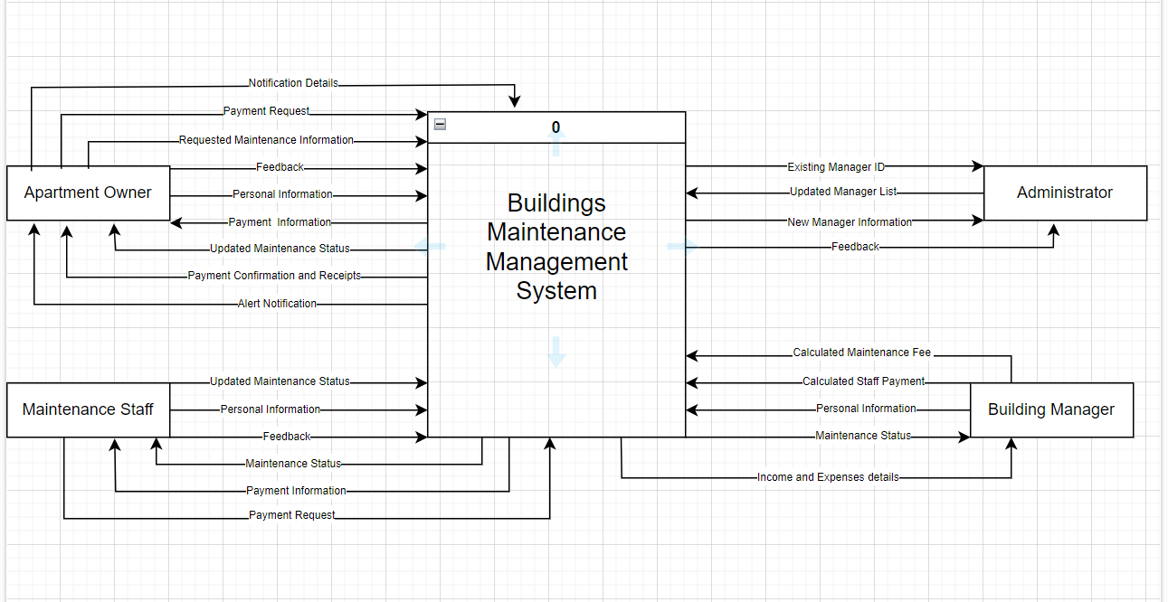

The context diagram of Building Maintenance Management System demonstrates how the main system process interacts with external entities, data flows, and exchanges information. The system method, "Building maintenance management system," is the most important part of the context diagram. This process is the central factor of the context diagram that happens and is done in the system. Moreover, there are 4 external actors which are Apartment Owner, Maintenance Staff, Building Managers, and Administrator that interact with the system process.
Apartment Owner uses the system for registering in the system, creating maintenance requests for the building, and making payments.
Maintenance Staff uses the system for registering in the system, managing maintenance requests and payment information.
Building Manager uses the system for registering in the system, calculating staff payment and maintenance fee based on income and expenses details.
Administrator uses the system for getting and managing all feedbacks from Apartment Owner, Maintenance Staff, and Building Manager, and updating building manager list such as adding, or removing.

UML Activity Diagram

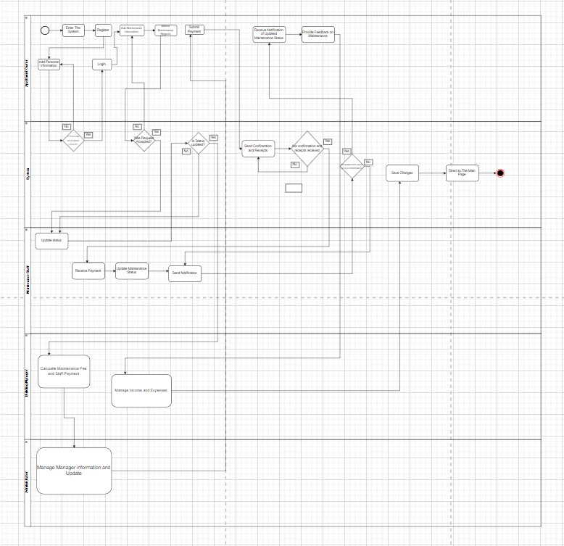

Level 0 diagram

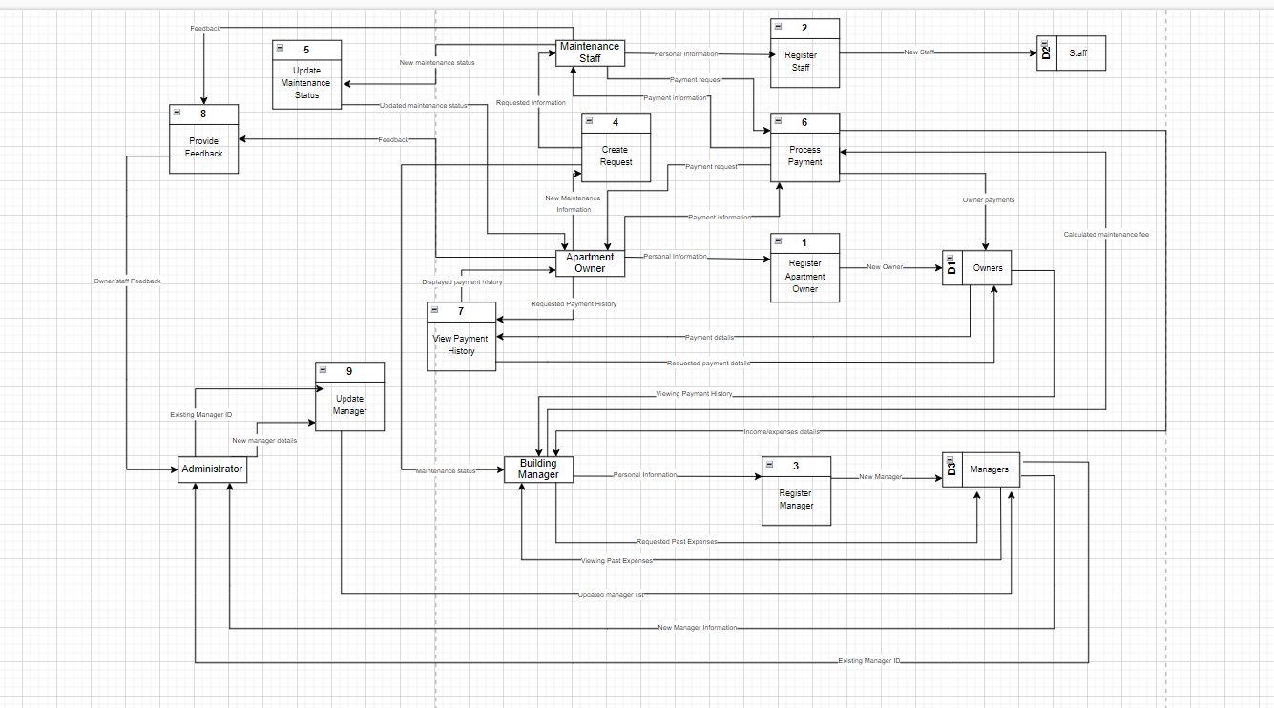

Level 1 diagrams

1.
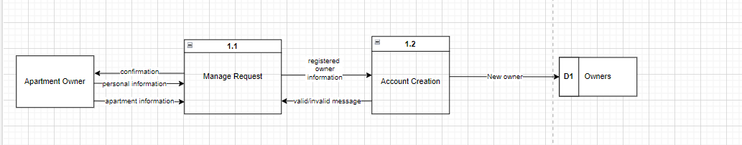

2.
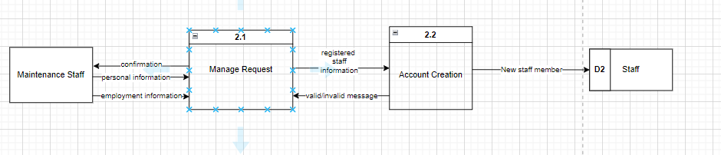

3.
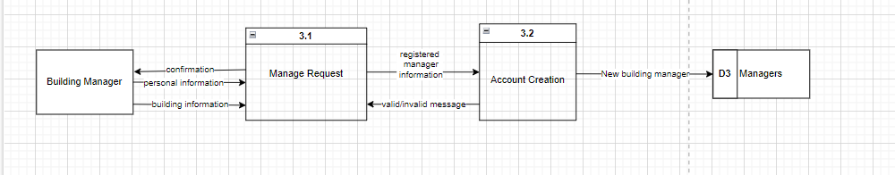

4.
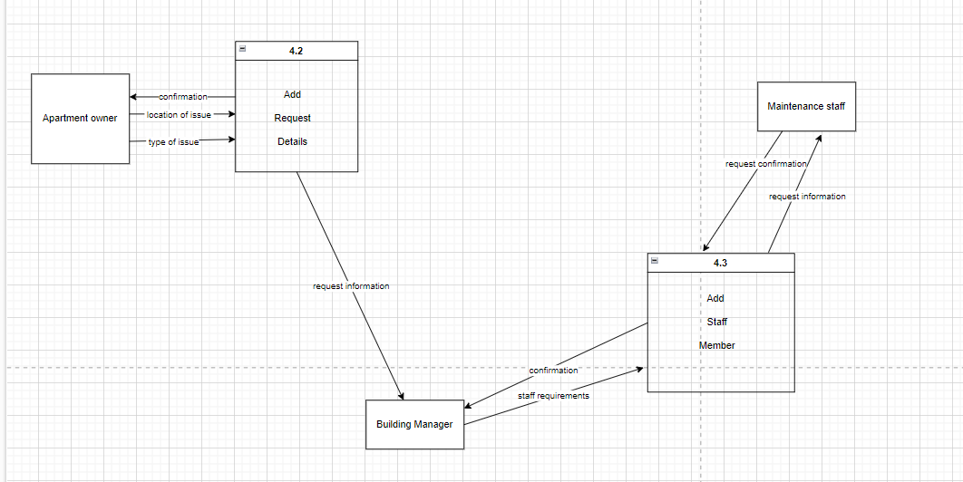

5.
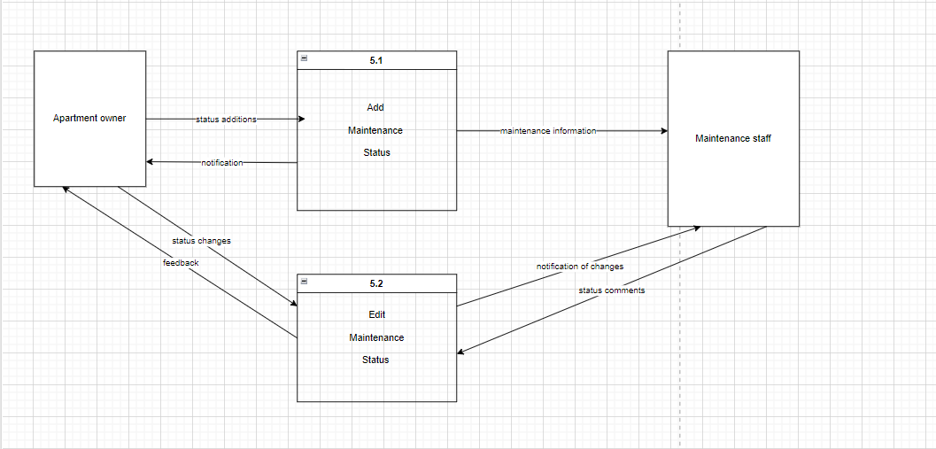

6.
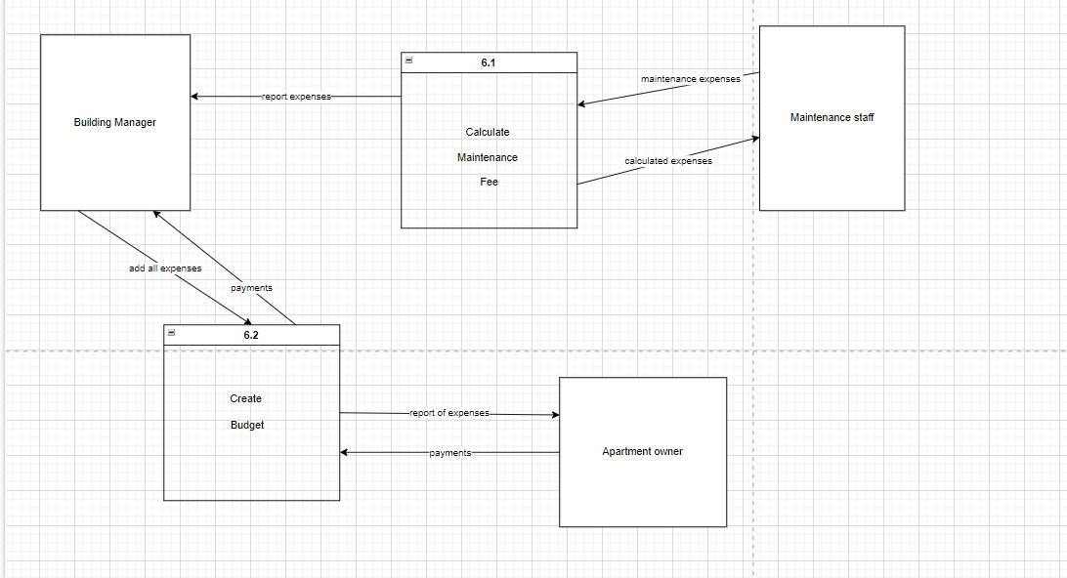

Data Modeling

UML Entity Relationship Diagram (ERD)

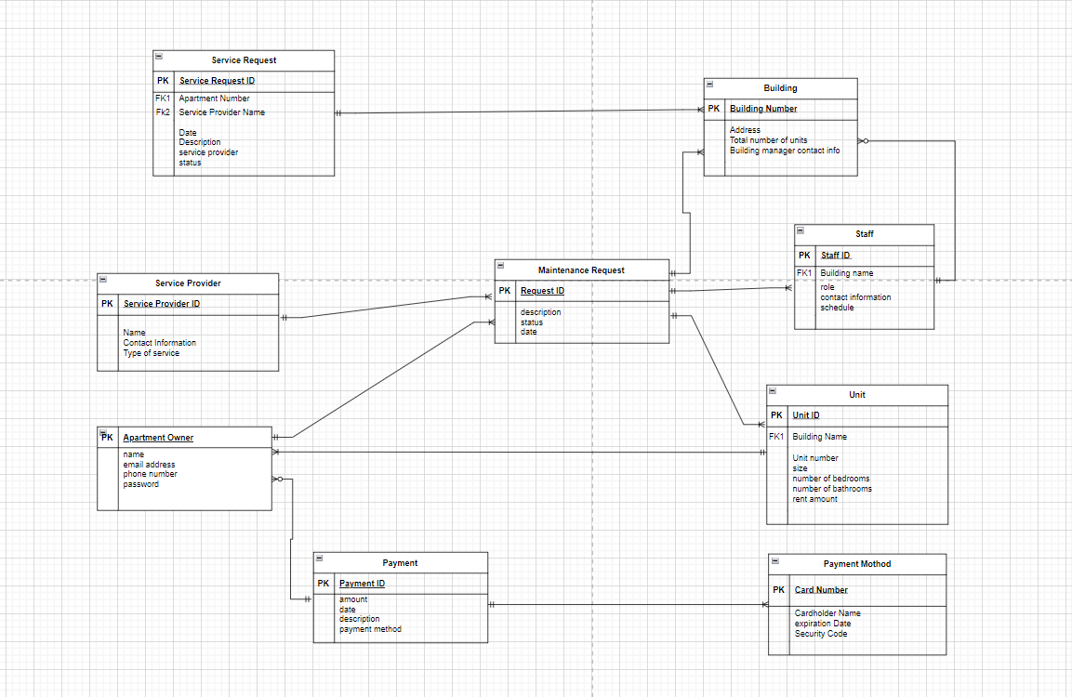

CRUD matrix

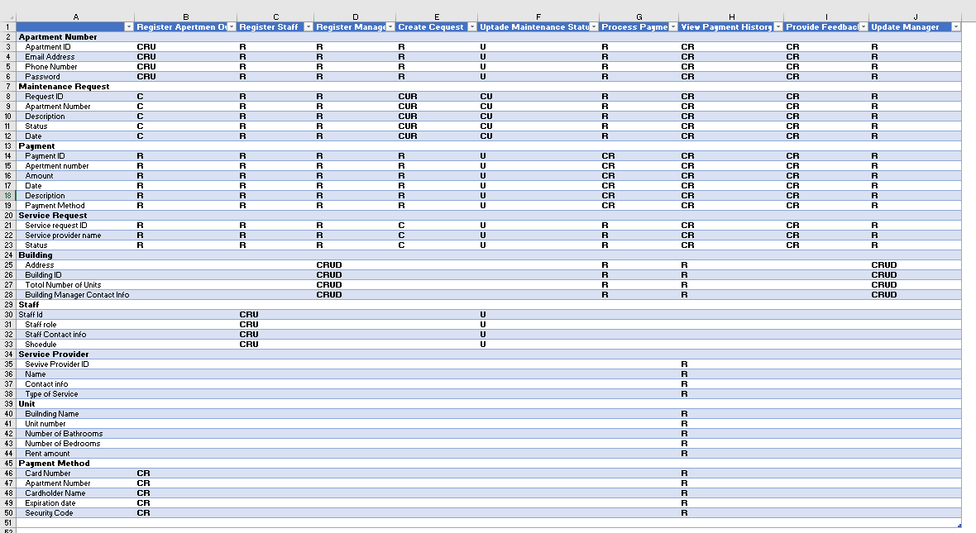

References

https://www.lucidchart.com/pages/data-flow-diagram

https://www.lucidchart.com/pages/er-diagrams

https://drawio-app.com/

Dennis, A., Wixom, B. H., & Roth, R. M. (2012). System analysis and design. Hoboken, NJ: John Wiley.(Chapter 5&6)

